St. John’s First World War Dead

~ Names in the same order as on the plaque~

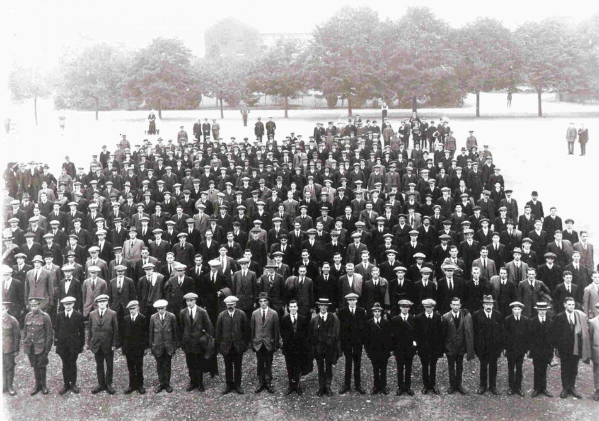
New recruits to the King’s Shropshire Light Infantry at Copthorne Barracks, Shrewsbury – 1914

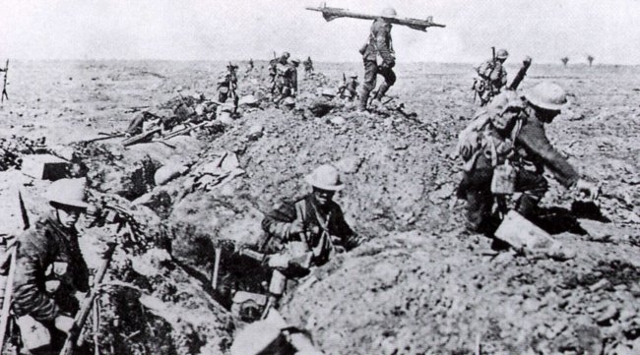
Men of the 1st King’s Shropshire Light Infantry on the Somme in 1916
St. John’s First World War Dead

James (Jim) Crewe

Birth Place: Whitchurch - 1898

Date of Death: 8th October 1917 – France/Flanders

Type of Casualty: Killed in action

Enlistment Location: Whitchurch

Rank: Private

Regiment: Machine Gun Corps

Service Number: 59856 – formerly No. 25060 Shropshire Light Infantry

Medals: Posthumously - Victory and British

Jim was the son of Richard and Mary Jane Crewe, and the brother of Dick, Bill, Maggie, Tom and George. His father was a bricklayer’s labourer and at the time of the 1911 Census all the children were ‘at school’ except Dick who was a 16 year-old ‘van boy’. The family, including lodger William Penk, aged 17 and working as an errand boy, were living at 9 Smallbrook Buildings, Whitchurch in 1911 (see copy of Census).

Resting Place: No grave - remembered at Tyne Cot Memorial

The TYNE COT MEMORIAL now bears the names of almost 35,000 officers and men whose graves are not known. The memorial, designed by Sir Herbert Baker with sculpture by Joseph Armitage and F.V. Blundstone, was unveiled by Sir Gilbert Dyett on 20 June 1927. The Tyne Cot Memorial to the Missing forms the north-eastern boundary of Tyne Cot Cemetery, which is located 9 kilometres north east of Leper (Ypres) town centre in present-day Belgium.
The original battlefield cemetery of 343 graves was greatly enlarged after the Armistice when remains were brought in from the battlefields of Passchendaele and Langemarck, and from a few small burial grounds. It is now the largest Commonwealth War Cemetery in the world in terms of burials.

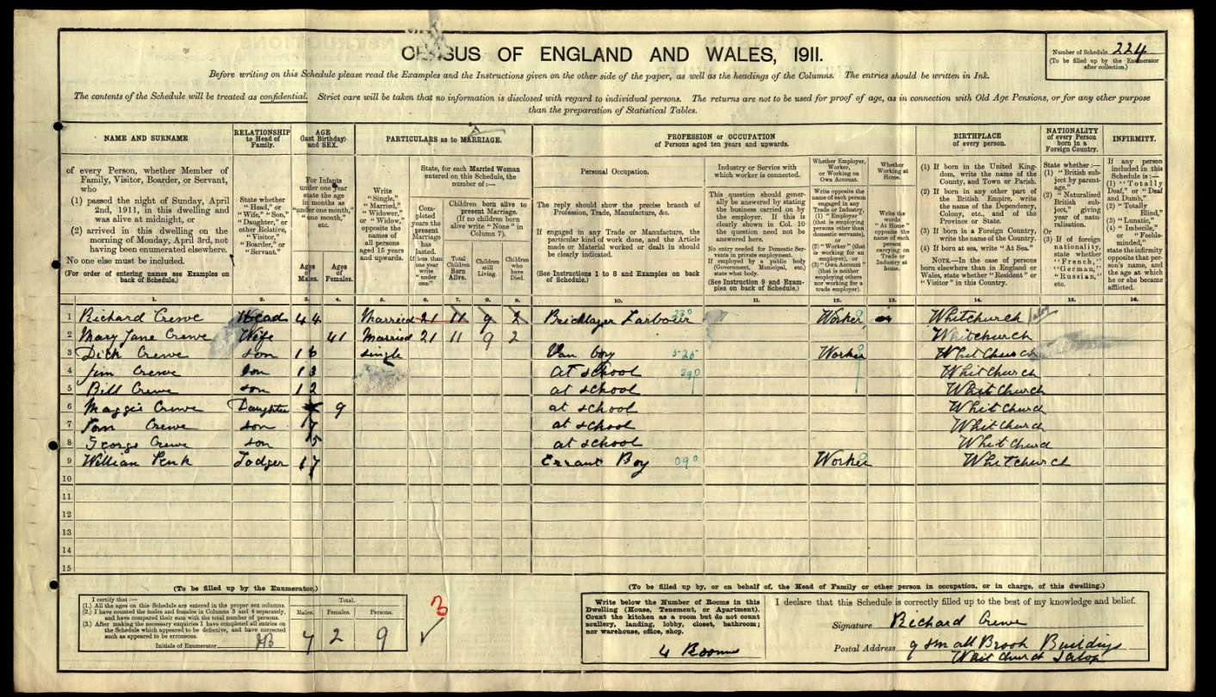

Jim Crewe: 1911 Census Record

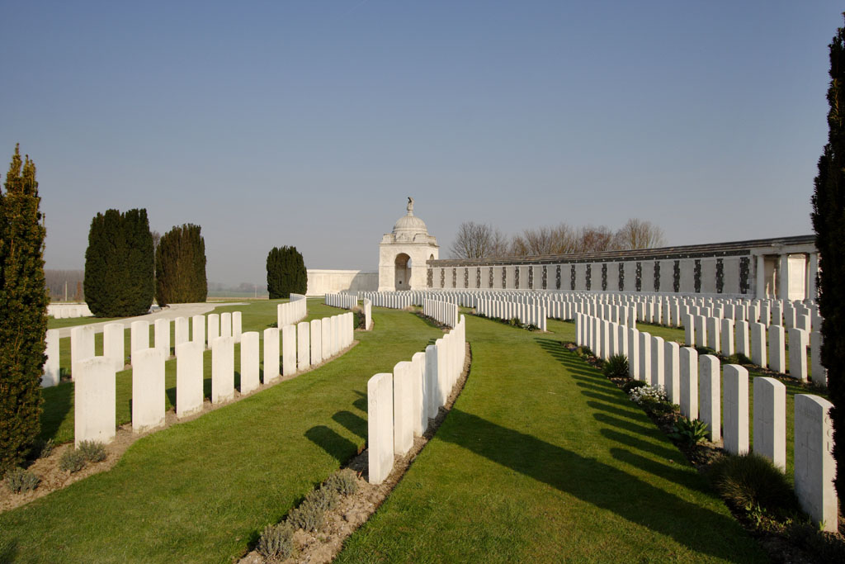

Tyne Cot Cemetery and War Memorial

St. John’s First World War Dead

Colin John Grindley

Birth Place: Whitchurch - 1896

Date of Death: 8th November 1918 – France/Flanders (3 days before the Armistice)

Type of Casualty: Died of disease

Enlistment Location: Shrewsbury

Rank: Private - Signaller

Regiment: King’s Shropshire Light Infantry (10th Battalion)

Service Number: 230434 – Formerly No. 2542 Shropshire Yeomanry

Colin was the son of John and Frances Grindley of (in 1911) 4 Worthington Street, Whitchurch. John was an ‘iron founder’s pattern maker’, and had another son, Rupert, who was a 19 year-old ironmonger’s clerk. Colin was still at school in 1911 (see Census).

Resting Place: Buried at Plot VII. D. 26 Terlincthun British Cemetery, Wimille near Bologne (see picture below).

The 10th Battalion KSLI took part in the second and third battles of Gaza, July-November 1917, and then in the capture of Jerusalem (December 1917) and the capture of Jericho (February 1918). In the attack on Birj-el-Lisaneh, near Tel Asur, on March 10th 1918, Private Harold Whitfield won the only VC awarded to a Shropshire regiment for the Great War.
In May 1918, the 10th went to France, serving on the Lys in August, and then at the Battle of Epehy on 18th September 1918.

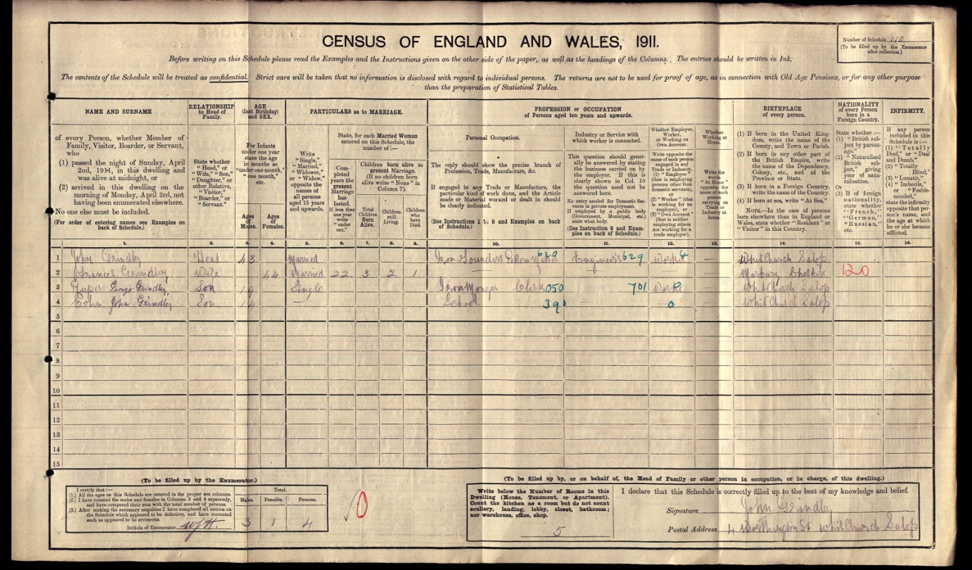

Colin John Grindley: 1911 Census Entry

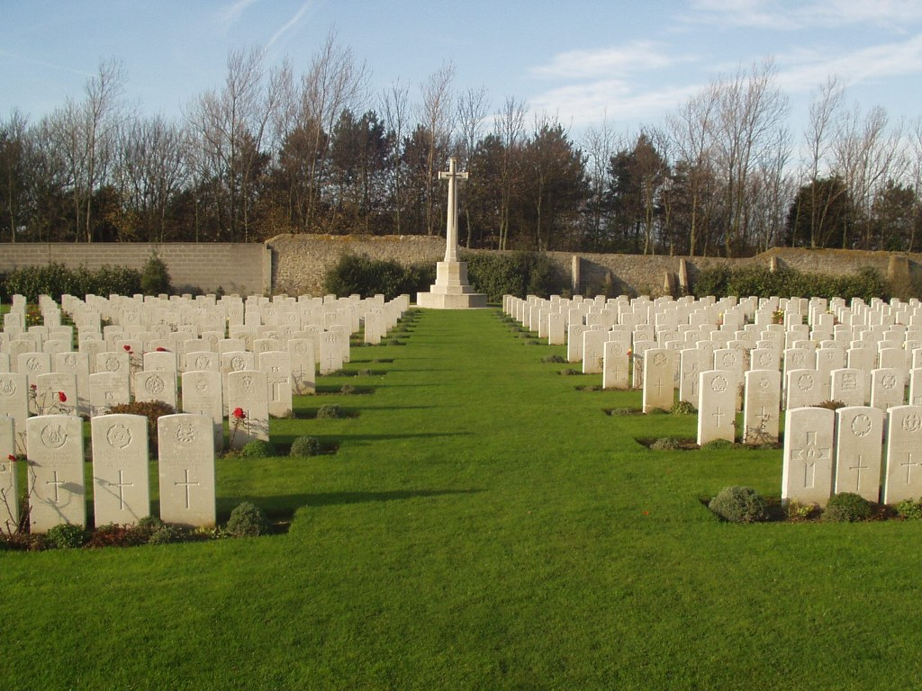

Terlincthun British Cemetery
St. John’s First World War Dead

John Thomas Jones

Birth Place: Oswestry - 1886

Date of Death: 1st July 1916 – France/Flanders

Type of Casualty: Killed in action

Enlistment Location: Oswestry

Rank: Private

Regiment: King’s Shropshire Light Infantry (6th Battalion)

Service Number: 12339

John was a slater, and lived at 12 Oswald Place, Upper Brook Street, Oswestry (3 rooms) with his wife Gertrude, his 7 month-old son Wynne Price Jones, and his brothers Edward and Wynne Clued (sic – probably actually Clwd) who were a plumber and a labourer respectively (see 1911 Census). John also had a daughter Hilda (b. 1906) and a son Edward (b. 1909) who were living with their grandparents at the time of the 1911 Census. It is not known what link John had with St. John’s – he was living with his parents Thomas Edward (a slater like John) and Sarah Ann (née Fardoe) at 24 Oswald Place, Oswestry at the time of the 1901 Census and working as a slater’s labourer, and in 1911 his parents were still living at Oswald Place in Oswestry, with two of John’s children a few doors down the road.

Resting Place: IIB.27 Vlamertinghe Military Cemetery, which is located 5 Kms west of Ieper (Ypres) town centre in present-day Belgium and was started by French troops in 1914 and taken over by Commonwealth forces in April 1915. It was used by fighting units and field ambulances until June 1917, when the land adjoining the cemetery was claimed for a military railway preventing further extension.
The cemetery now contains 1,175 Commonwealth burials of the First World War. The French graves were removed after the war, but three German war graves remain. There are also four Second World War burials dating from the Allied retreat to Dunkirk in May 1940.
The cemetery was designed by Sir Reginald Blomfield. The wrought iron gates were presented by the family of the late Lord Redesdale, whose son, Major Mitford, is buried in the Cemetery.

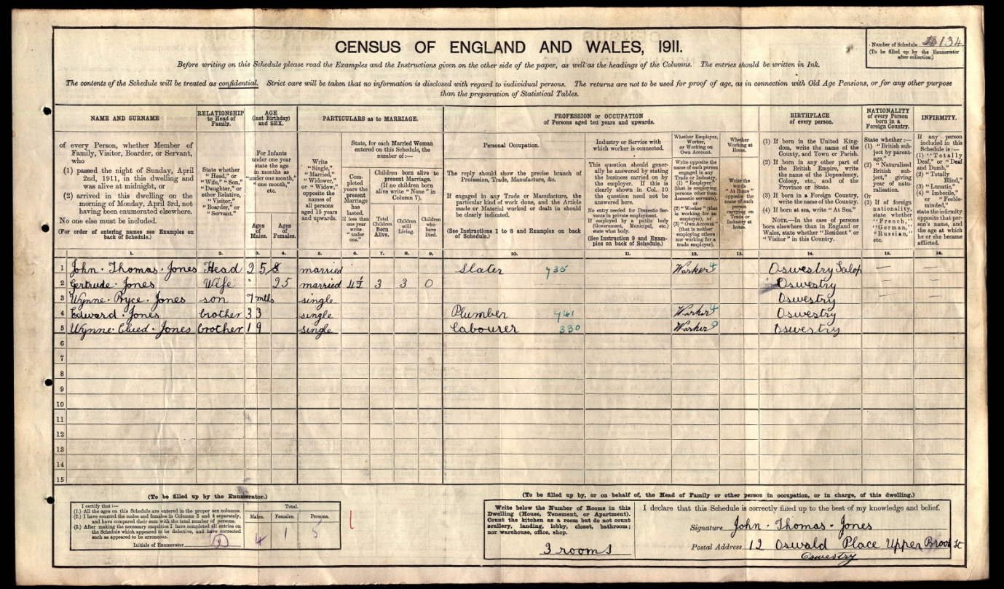

John Thomas Jones: 1911 Census Record

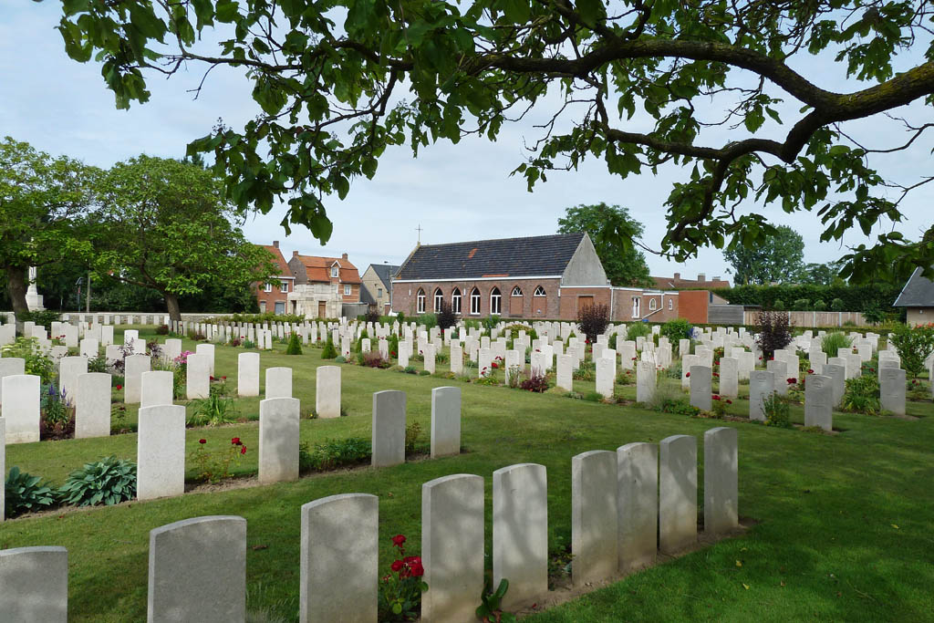

Vlamertinghe Military Cemetery

St. John’s First World War Dead

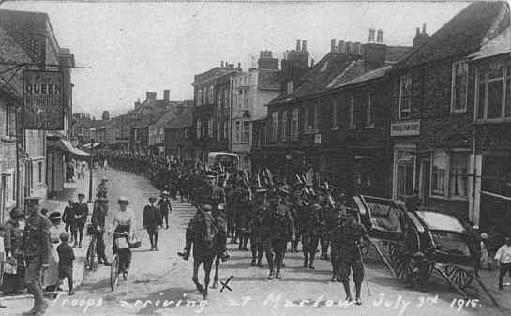
Douglas Arthur Oulton

Birth Place: Tarporley (Eaton) - 1893

Date of Death: 20th July 1917 – France/Flanders

Type of Casualty: Died of wounds
3rd and 4th Battalion Grenadier Guards arriving at Marlow, Bucks. on 3rd July 1917 before departure to France on 14th July

Enlistment Location: Chester

Rank: Guardsman

Regiment: Grenadier Guards (4th Battalion) Service Number: 14345

Douglas, aged 18, was working as an iron foundry clerk and living on the farm of Henry Willis and his wife Annie on Tarporley Road, Whitchurch at the time of the 1911 Census (see below). Also living at the house were his mother Mary (née Sheen - Mrs. Willis’s sister), and his younger brother Frank, who was a farm worker. Douglas’s mother was recorded as having 5 children still alive, and as still being married rather than widowed, although no husband was recorded for her in 1911. Douglas’s father was Thomas Nuttall Oulton, a farmer at Eaton, b. 1859 in Nantwich, but no death records have been identified for him. In 1901 Douglas was living, as well as his brother Frank, on the farm of his Uncle Albert Willis at Ridley, where his mother was housekeeper. She was recorded as married on this occasion also, but no record has been identified for Douglas’s father at this time either.

Place of Rest: Buried in Bleuet Farm Cemetery. The cemetery is located to the north west of the town of Ieper (Ypres) near a village called Elverdinge. Bleuet Farm was used as a dressing station during 1917 Allied offensive on this front. The cemetery was begun in a corner of the farm and was in use from June to December 1917, though a few of the burials are of later date. Two graves were brought into the cemetery after the Armistice from isolated positions close by. There are now 442 First World War burials in the cemetery and nine from the Second World War, all dating from the Allied retreat to Dunkirk in May 1940. The cemetery was designed by Sir Reginald Blomfield.
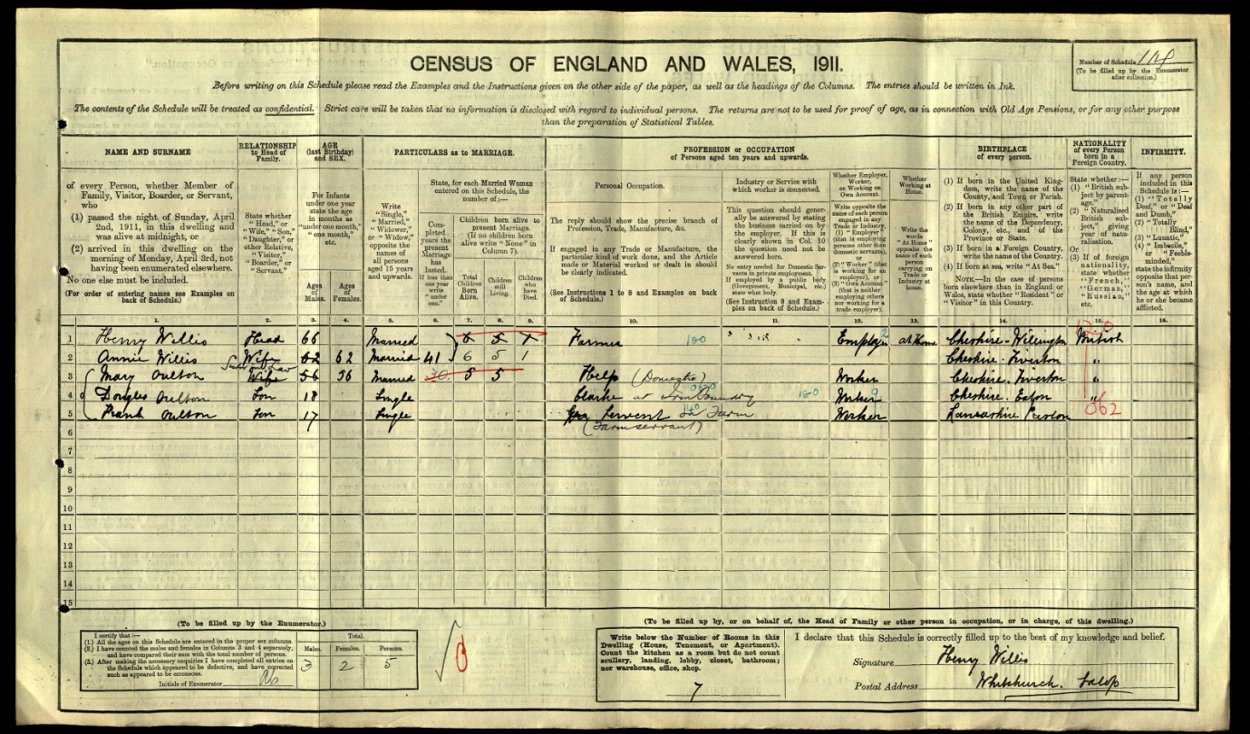

Douglas Arthur Oulton: 1911 Census Record

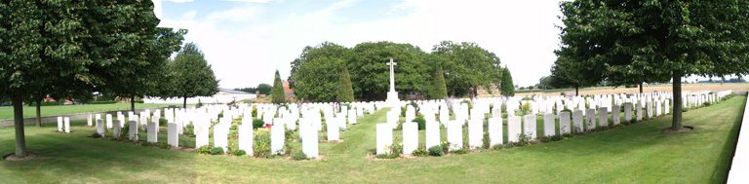

Bleuet Farm Cemetery

The 4th Battalion Grenadier Gurads moved to France 14 July 1915. On 19th August 1915 they came under the command of 3rd Guards Brigade, Guards Division. During Douglas Oulton’s service they were in action in The Battle of Loos, and in 1916 they fought on The Somme in both The Battle of Flers-Courcelette and The Battle of Morval, capturing Lesboeufs. In 1917 they were in action during the German retreat to the Hindenburg Line, and the Third Battle of Ypres (Passchendaele) which took place from July-November 1917, so was probably the action in which Douglas Oulton sustained the wounds that killed him.

St. John’s First World War Dead

Robert Hales Ridgeway

Birth Place: Whitchurch - 1896

Date of Death: 12th April 1918 – France/Flanders

Type of Casualty: Killed in action

Enlistment Location: Liverpool

Rank: Private

Regiment: King’s Liverpool (10th Battalion)

Service Number: 356308

Robert was the son of Robert Dicken Ridgeway and his wife Mary Ann (née Hales). He was baptised on 12th July 1896, in St. John’s Church. At the time of the 1911 Census (see below) he was a schoolboy aged 14, living at 16, Worthington Street, Whitchurch with his father (a carpenter and wheelwright), his mother, and his 17 year-old brother Clement, an ironmonger’s apprentice.

Resting Place: Commemorated on Panels 27-30 of the Loos Memorial (see below), which forms the sides and back of Dud Corner Cemetery. Loos-en-Gohelle is a village 5 kilometres north-west of Lens, and Dud Corner Cemetery is located about 1 kilometre west of the village.
Dud Corner Cemetery stands almost on the site of a German strong point, the Lens Road Redoubt, captured by the 15th (Scottish) Division. The name "Dud Corner" is believed to be due to the large number of unexploded enemy shells found in the neighbourhood after the Armistice.
The Loos Memorial commemorates over 20,000 officers and men who have no known grave, who fell in the area from the River Lys to the old southern boundary of the First Army, east and west of Grenay. On either side of the cemetery is a wall 15 feet high, to which are fixed tablets on which are carved the names of those commemorated.
The memorial was designed by Sir Herbert Baker with sculpture by Charles Wheeler. It was unveiled by Sir Nevil Macready on 4 August 1930.
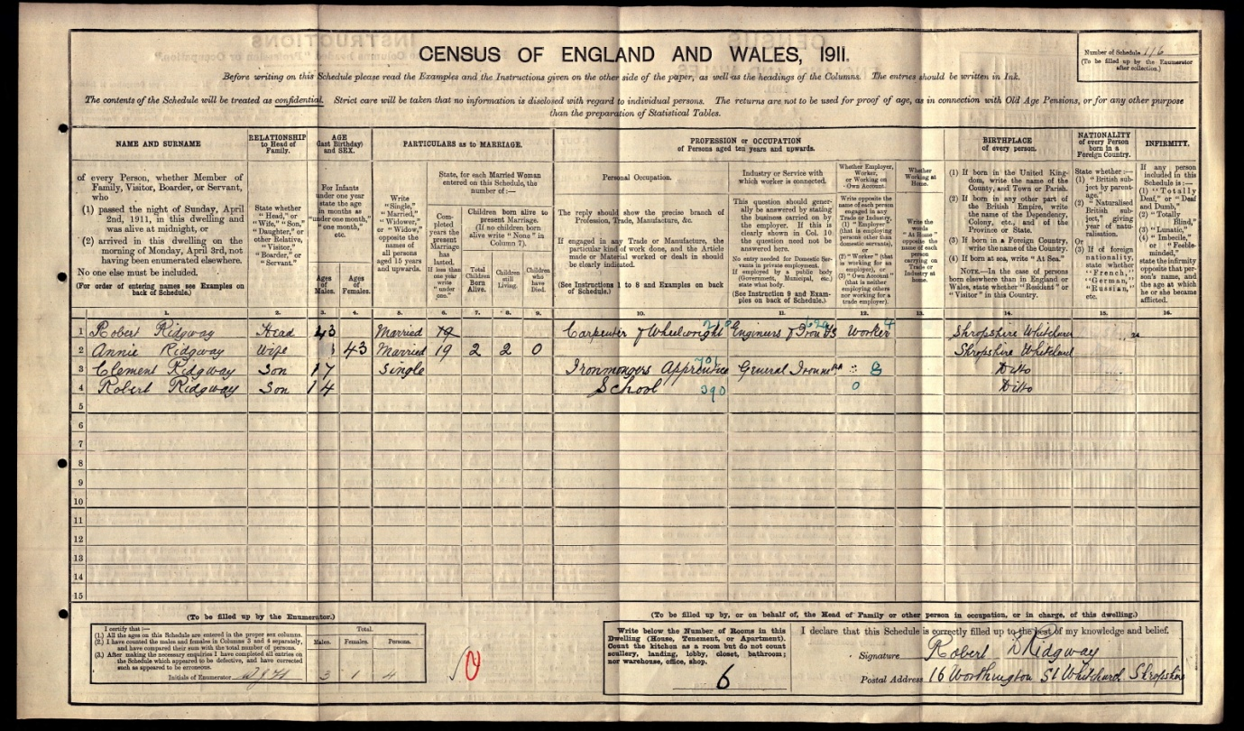

Robert Hales Ridgeway: 1911 Census

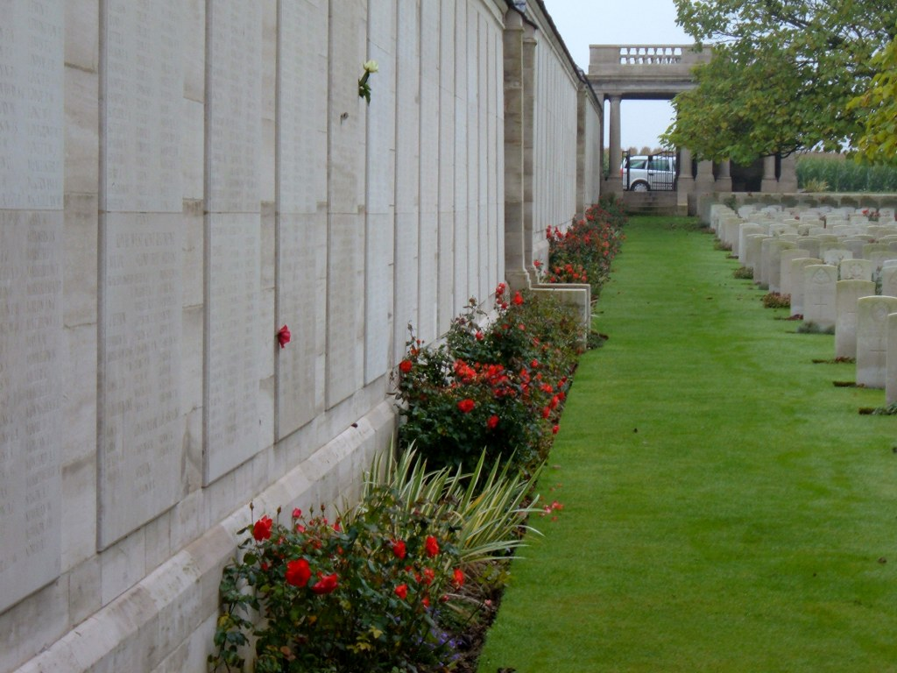
Loos Memorial
St. John’s First World War Dead

Arthur Beech Steele

Birth Place: Whitchurch – 1886

Date of Death: 30th December 1917 – France/Flanders (Somme)

Type of Casualty: Killed in action

Enlistment Location: Whitchurch

Rank: Corporal

Regiment: King’s Shropshire Light Infantry

Service Number: 31277

Arthur was the son of blacksmith George Steele and his wife Mary, of 18 Egerton Road, Whitchurch. Arthur married May Lloyd in 1907 in Whitchurch, and the 1911 Census records Arthur, aged 24 and working as a boilermaker’s labourer (working for a railway company) living at 22 Asquith Street, Reddish (Stockport) with his wife May, also 24 years of age, (and born in Whittington), plus their two children Gladys May, 3yrs 8 months old, and George Beech, 1 year and 7 months old. Both children were recorded as born in Whitchurch, so the family’s move in Stockport was relatively recent in 1911. At the time of Arthur’s death, May and the children were living at 14 Priory Lane, Reddish.

Resting Place: Commemorated on Pier and Face 12A and 12D of the Thiepval Memorial, next to the village of Thiepval, off the main Bapaume to Albert road. This is the Memorial to the Missing of the Somme, and bears the names of more than 72,000 officers and men of the United Kingdom and South African forces who died in the Somme sector before 20 March 1918 and have no known grave. Over 90% of those commemorated died between July and November 1916. The memorial also serves as an Anglo-French Battle Memorial in recognition of the joint nature of the 1916 offensive and a small cemetery containing equal numbers of Commonwealth and French graves lies at the foot of the memorial.
The memorial, designed by Sir Edwin Lutyens, was built between 1928 and 1932 and unveiled by the Prince of Wales, in the presence of the President of France, on 1 August 1932.
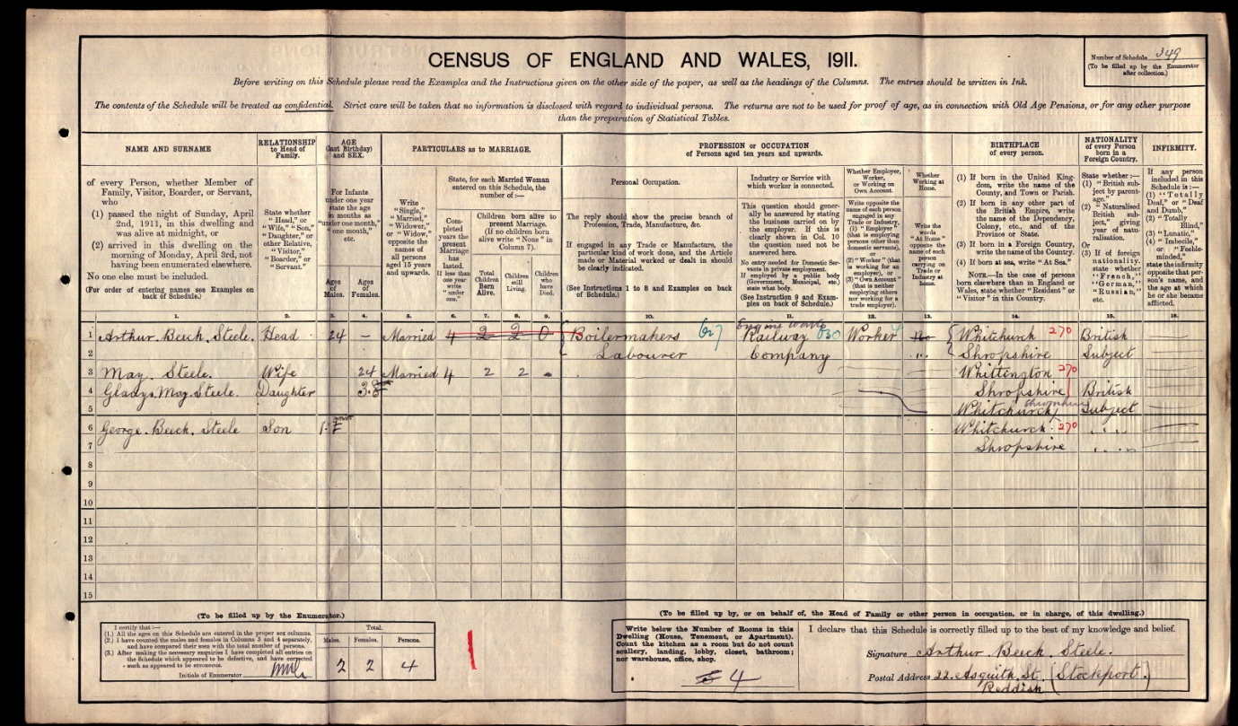

Arthur Beech Steele: 1911 Census Record

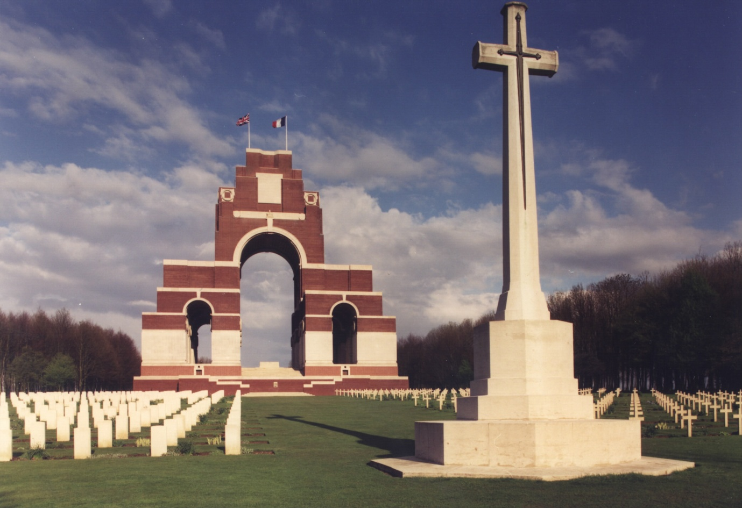

Thiepval Memorial
St. John’s First World War Dead

George Caldecott Taylor

Birth Place: Whitchurch – 1890

Date of Death: 17th July 1916

Type of Casualty: Died at the Military Hospital Prees. Buried in Whitchurch

Enlistment Location: Altrincham

Rank: Acting Sergeant

Regiment: 2/5th Battalion Cheshires (Earl of Chester’s) - Territorials

Service Number: 3074

George’s father William (1849-) was a master butcher living on Whitchurch High St. in 1891, at 7 Bargates in 1901, and at 62 High Street again in 1911. His mother was Arena (née Caldecott 1851-1901), and he had older sisters Sarah and Marian, and older brothers Alfred and Theodore. In 1911 Marian was an elementary school teacher. George’s home address was 69 Talbot Street, Whitchurch at the time of his death, and probate was awarded to Corporal Samuel Whitehead of the Royal Garrison Artillery. His effects amounted to £230:5/5d. No 1911 Census entry has been identified for George.
In typical British county regiments, the 1st and 2nd Battalions were regular army, and the 3rd was the special reserve battalion which did not normally serve overseas but remained at home as the regimental depot and training unit from which replacements were sent to the regular battalions. The 4th, 5th and 6th Battalions were normally Territorial Force battalions. Territorial battalions raised second line battalions which would be numbered 2/4th, 2/5th and 2/6th, initially from men who did not volunteer for overseas service. The terms of service in the Territorial Force meant that men who had signed up on these could not be forced to serve outside the United Kingdom.
The 2/5th Cheshires was formed at Chester on 28 November 1914 as a home service ("second line") unit and disbanded on 21st April 1918, so it seems that George served in a support unit of some kind and would not have seen frontline service outside the UK.
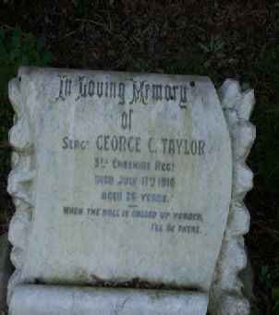

George Caldecott Taylor’s grave in St. Alkmund’s graveyard
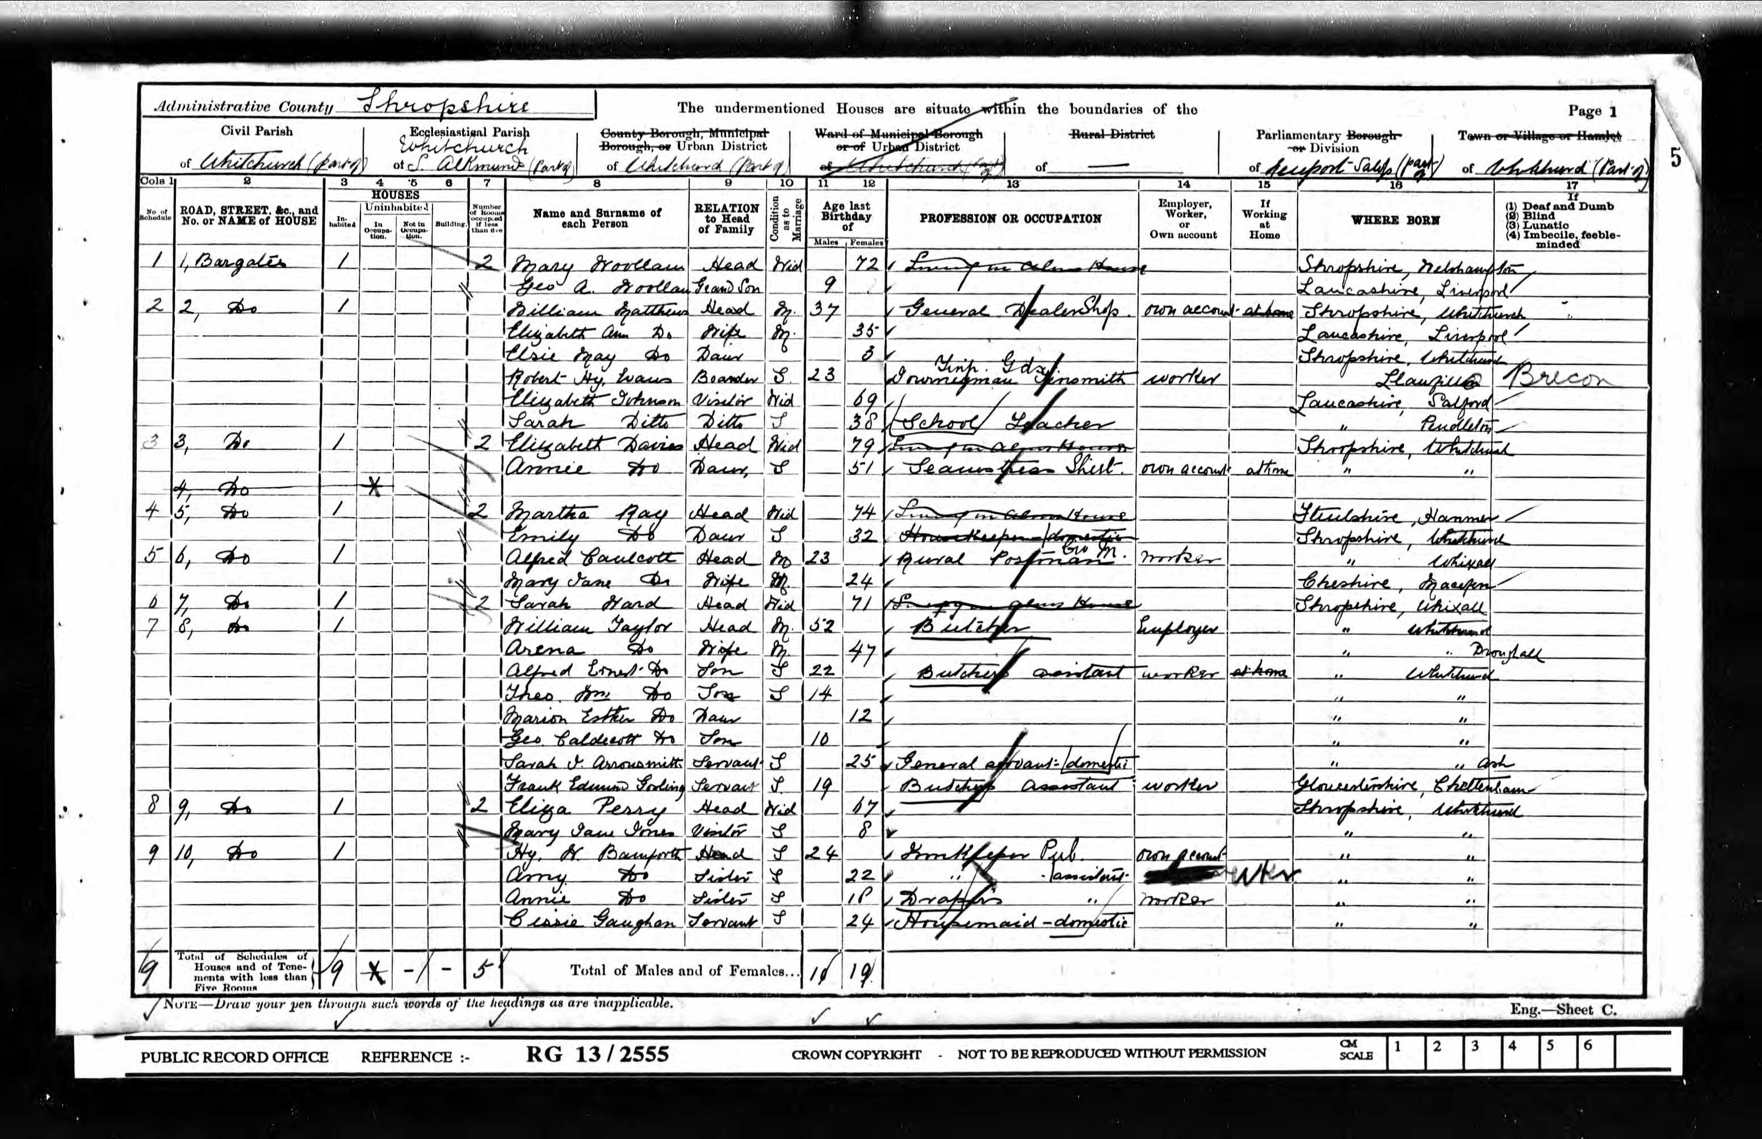
George Caldecott Taylor: 1901 Census record
(Overleaf: An enlarged portrait of George on a wartime postcard, and a postcard from George to his friend Alfred Ronald Wild (1891-1976) - (the father of Elsie Mary Wild (1933- 2015) - a lifelong member of St. John’s).
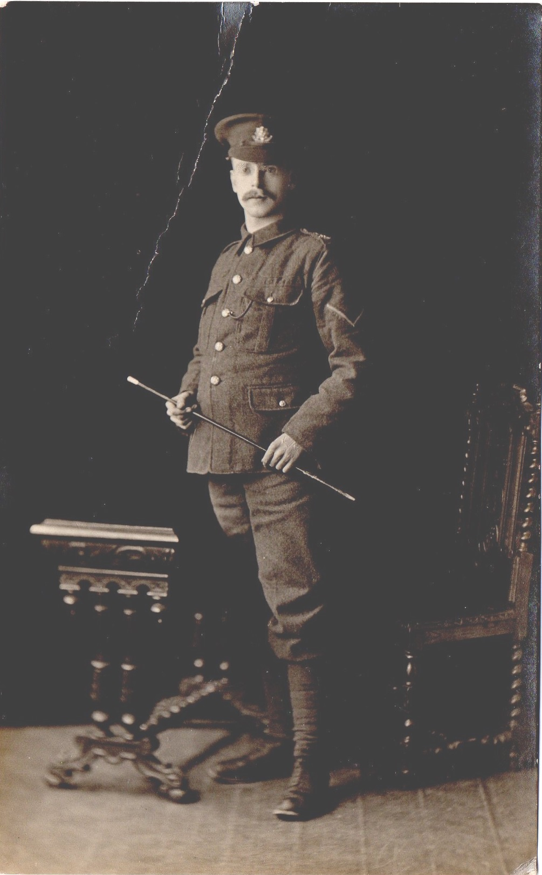
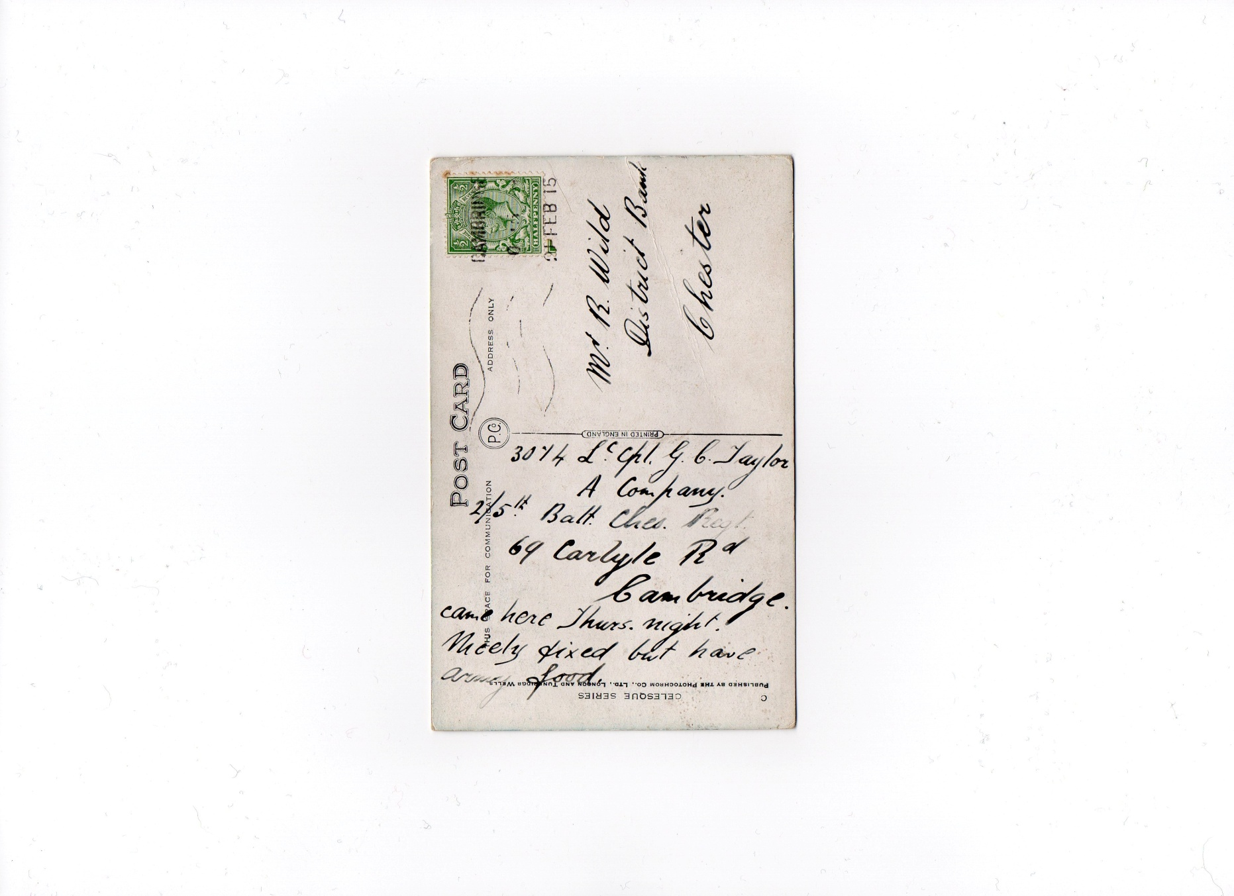

St. John’s First World War Dead

Reginald Arthur Trickett

Birth Place: Oldham – 1893

Date of Death: 27th November 1917 – France/Flanders

Type of Casualty: Killed in action

Enlistment Location: Chester

Rank: Private: Guardsman

Regiment: Grenadier Guards: 3rd Battalion

Service Number: 24237

Reginald was the son of railway labourer John Trickett of Southport, and Ada (from Salford), and was living, aged 8, at 9 St. John’s Street, Whitchurch on 31st March 1901 with his mother and sister Elizabeth Ann Stella, aged 1 (b. Oldham) (see Census). In 1911 Reginald’s mother was back living with his father at 14 Robinson St. Horwich, but Reginald was not with them and no 1911 Census entry has been found for him.

Place of Rest: Cambrai Memorial, Louverval (no grave)
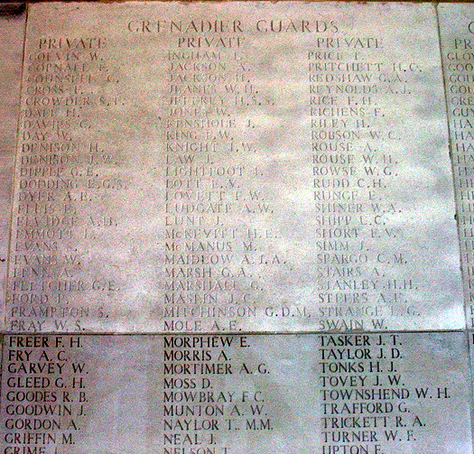
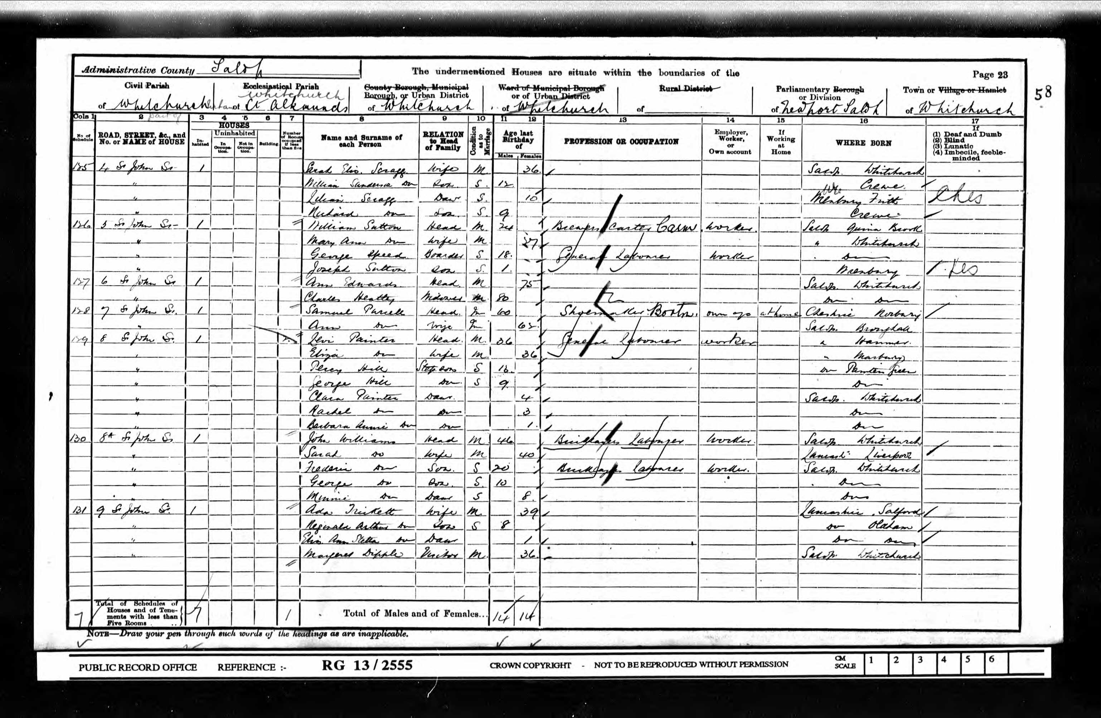
Reginald Arthur Trickett: 1901 Census Record

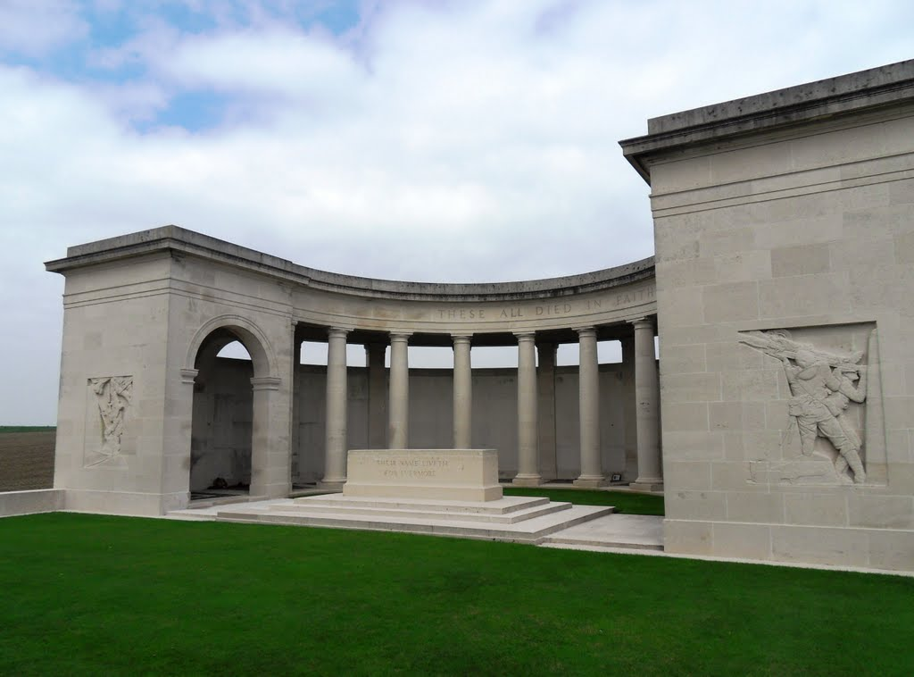
Cambrai Memorial
St. John’s First World War Dead

Harry Jack Venables

Birth Place: Whitchurch – 1894

Date of Death: 15th November 1918 in Ipswich (the East Suffolk and Ipswich Hospital was used for casualties during World War 1) – buried in St. Alkmund’s graveyard, Whitchurch.

Type of Casualty: Not known

Enlistment Location: Whitchurch

Rank: Private

Regiment: 3/4th King’s Shropshire Light Infantry Service Number: 4538

Harry Venables was a cheese factor’s clerk in 1911, aged 16, and living at Glendale House, Talbot St. Whitchurch (see Census). He was the great-grandson of the confectioner Samuel Venables (1802-66) who is named in one of the stained glass windows above the altar in St. John’s. His parents were Samuel Hughes Venables (1863-1907) and Sarah Jane Williams (1861-1934), who ran a grocery and confectioner’s at 60 High St. Whitchurch in 1901. Harry Venables’s address at the time of his death was recorded as 34 Talbot St. Whitchurch, although he died in Ipswich. Probate was awarded to his mother – effects £119:13/6d.
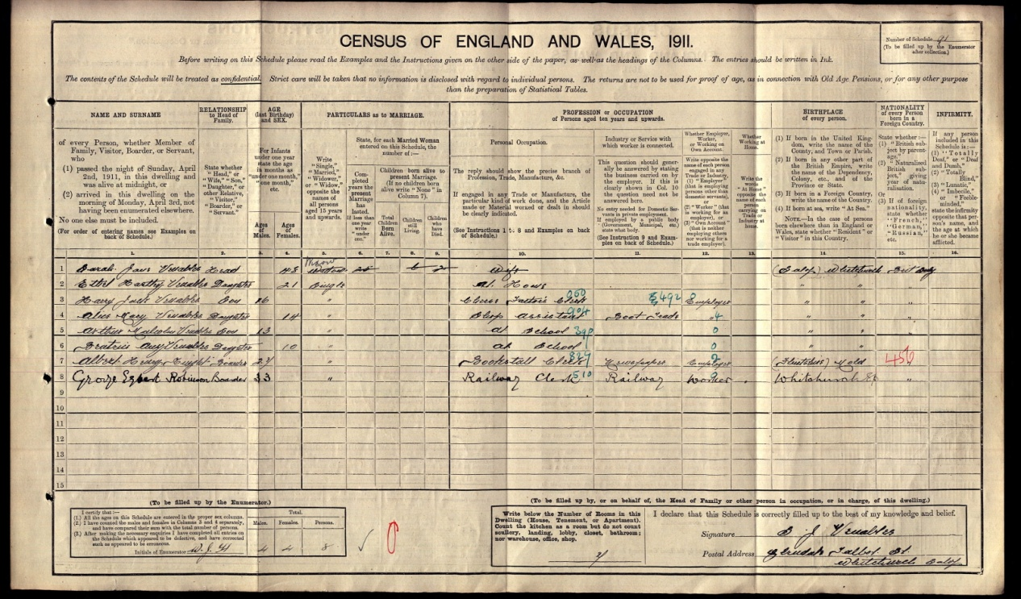
Harry Jack Venables: 1911 Census Record
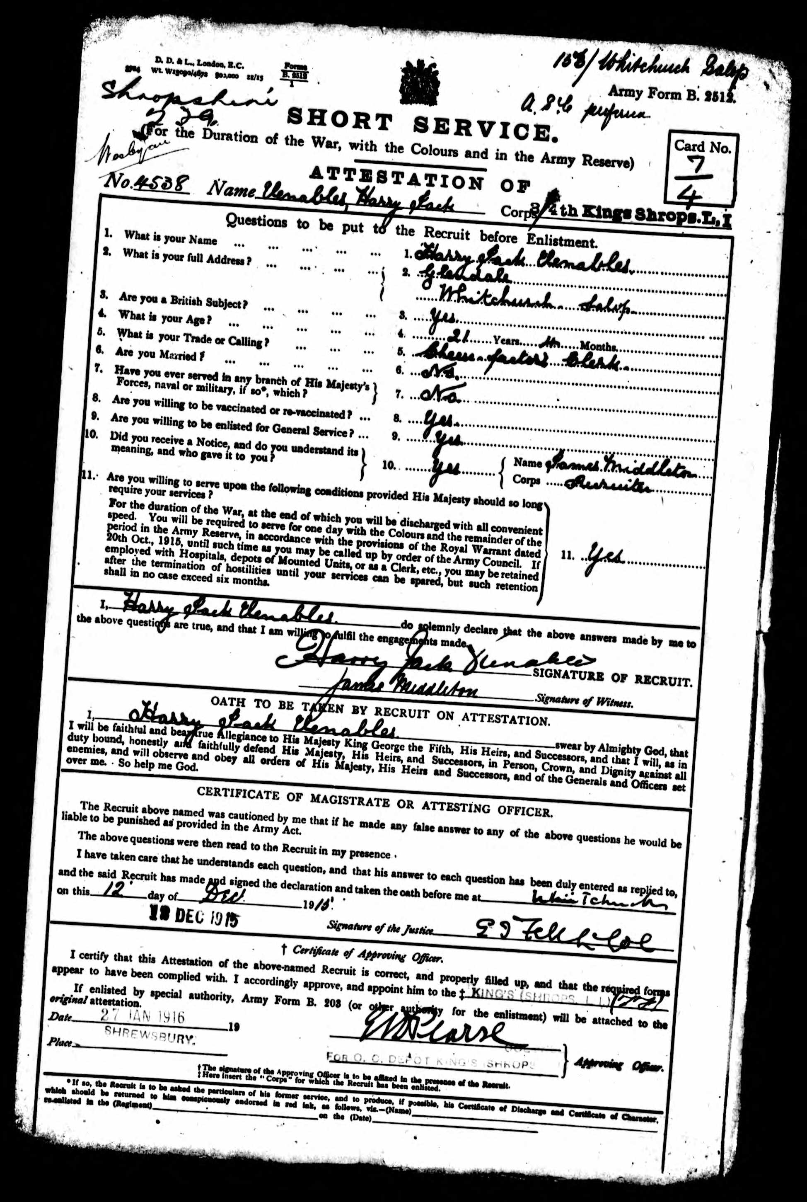
Harry Jack Venables: Joining Papers
St. John’s First World War Dead

George Edmund Vickers

Birth Place: Whitchurch – 1899

Date of Death: 9th February 1918 - Ipswich

Type of Casualty: Died - i.e. probably of disease rather than killed in action

Enlistment Location: Whitchurch

Rank: Private

Regiment: Household Cavalry - Denbighshire Hussars Battalion

Service Number: 38496

George was the son of blacksmith Edmund Joseph Vickers (1864-1908) and Ellen Walford (1866-1932), and was living, aged 12, with his parents at 34 Worthington St. Whitchurch on April 2nd 1911. Also in the household were his older brother Frederick, 16, a tin-smith’s apprentice, and his younger brother Albert, 9, and widower boarder John France, 73, a retired farmer. The East Suffolk & Ipswich Hospital was used for casualties during World War 1, so this may account for the place of death of George.
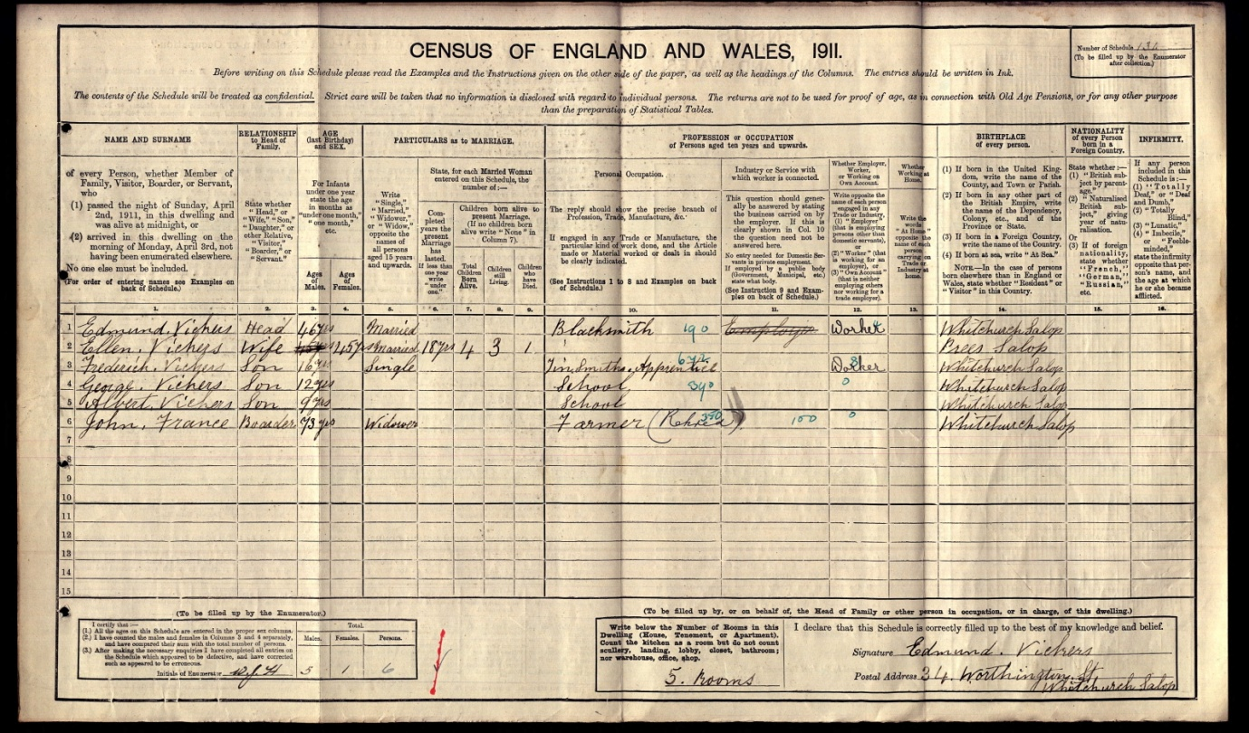
George Edmund Vickers: 1911 Census Record
St. John’s First World War Dead

Geoffrey Frank Willett

Birth Place: Ellesmere – 1894 (1901 Census records Nantwich as Geoffrey’s place of birth, but the only suitable record is for Ellesmere Registration District, and sister Phyllis Annie is recorded as b. Ellesmere in 1911 Census)

Date of Death: 12th September 1918 in France/Flanders

Type of Casualty: Died (i.e. not killed in action) – probably from disease

Enlistment Location: Shrewsbury

Rank: Private

Regiment: King’s Shropshire Light Infantry (7th Battalion)

Service Number: 19760

Geoffrey was the uncle by marriage of Kathleen Parbutt (1911-2008) who attended St. John’s for many years. He married Martha E. Stockton in Whitchurch in 1916. Martha was living in Worthington St. Whitchurch in 1911 with her engine-driver father Joseph and her mother Ann, plus her sister Lily and her husband Ernest Harry Parbutt – a grocer’s assistant. Lily and Ernest were the parents of Kath Parbutt. Geoffrey was the son of bookseller Frank Willett and his wife Annie Jane, who were living at 36 Park View Nantwich on 31st March 1901. No 1911 Census entry has been identified for Geoffrey.

Resting Place: Plot D75 Denain Cemetery. Denain is a town near to Valenciennes, and was a German hospital centre during the greater part of WW1. From the 1st November 1918 to the 12th March 1919, the 33rd Casualty Clearing Station was posted in the town. The Communal Cemetery, was used by the Germans to bury their soldiers and (in 1917/8) 153 British prisoners. A British plot was made at the South-East end, after the capture of the town; and after the Armistice the graves of the prisoners and other British graves were regrouped beside it. There are now over 300 1914-18 war casualties commemorated in this site. Of these, more than ten are unidentified, and special memorials are erected to four United Kingdom and three Canadian soldiers, buried in the German plots, whose graves could not be found.

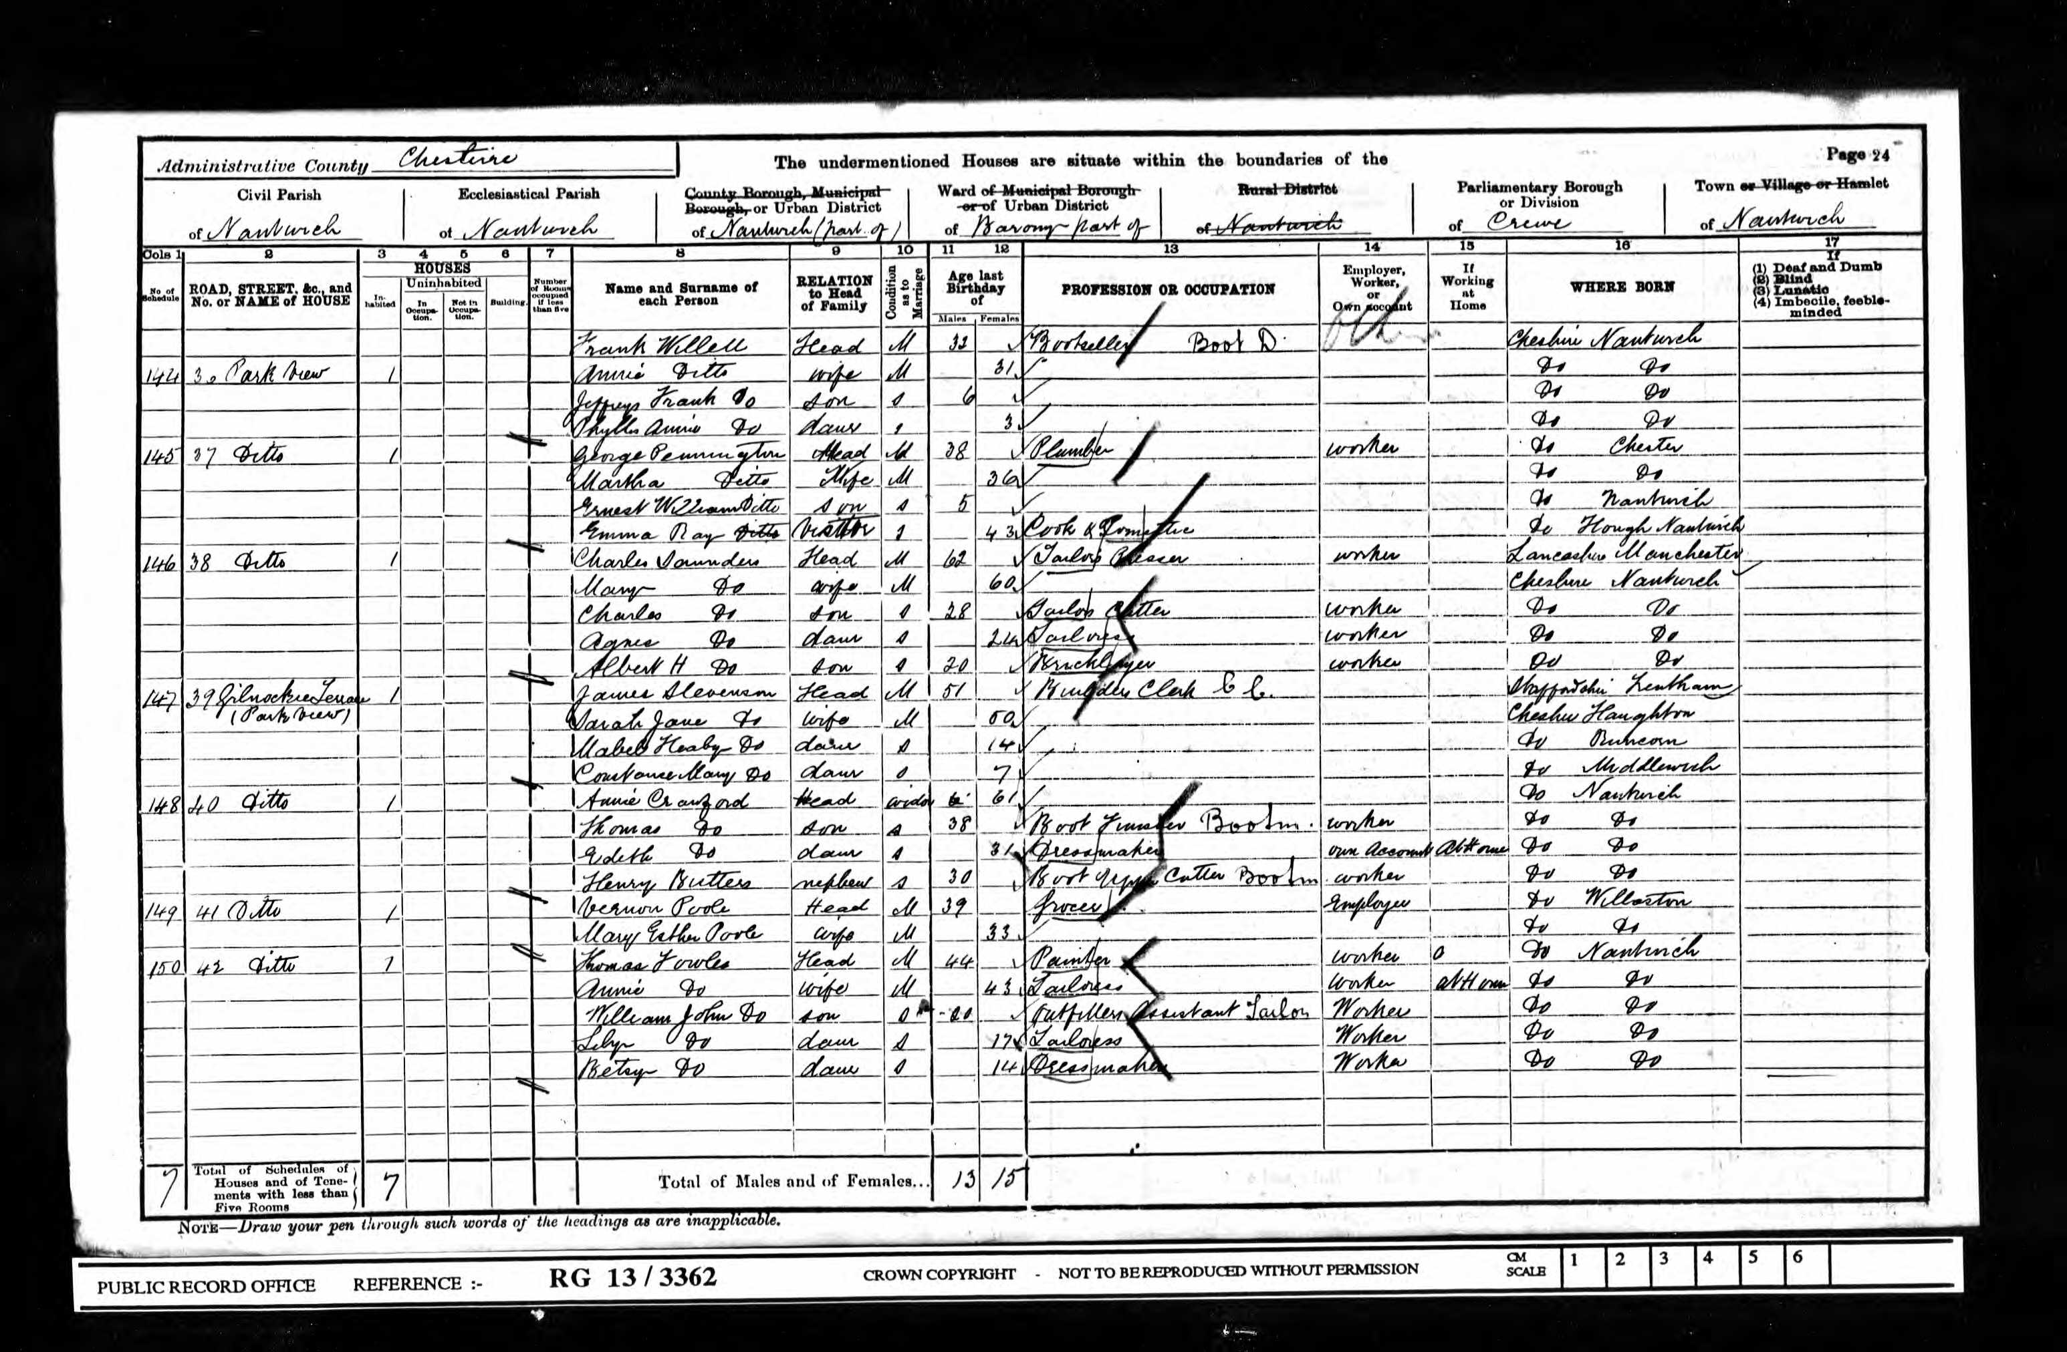

Geoffrey Frank Willett: 1901 Census Record

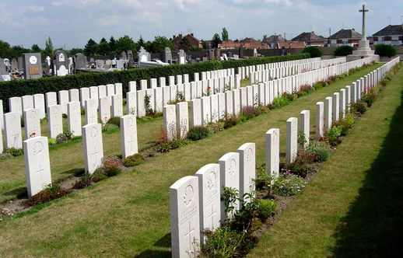

Denain Cemetery

St. John’s First World War Dead

William Ernest Burrows

Birth Place: Whitchurch – 1892

Date of Death: 15th July 1916 – Somme battlefield

Type of Casualty: Killed in action

Enlistment Location: Whitchurch

Rank: Rifleman

Regiment: King's Royal Rifle Corps Service Number: C/460

William was the son of ‘man from the PRU’ George Palmer Burrows and his wife Emma. On 2nd April 1911 William was recorded as an 18 year-old ironmonger’s clerk living with his parents at 24 Worthington St. Whitchurch. Also living in the house was boarder Florence Mandry from London, a 28 year-old milliner.

Resting Place: Thiepval Memorial to the Missing (no grave)

Although William’s army record shows him as having been in the Combat Logistics Division when he died, no such unit has been identified in the KRRC, and a Regimental History lists him among the men of the 16th (Service) Battalion (Church Lads Brigade) who fell on Saturday 15th July 1916 in the Battle of Bazentin Ridge. Interestingly, it seems likely that William fought alongside James Hockenhull of Castle Hill Chapel until James was killed in March 1916, four months before his own death.

“Temperature 72°F, morning mist clearing to a bright day. 16th (Service) Battalion (Church Lads' Brigade), 100th Brigade & 33rd Division. The 100th Brigade attacked with the 9th Highland Light Infantry on the left, in the front line, the 16th KRRC being in support. The Highland Light Infantry were held up from the start by enfilade fire from High Wood. The Queen's reached the enemy's wire, and found it uncut. Our 16th Battalion was then put in to fill the gap between the two regiments. They advanced 1,000 yards over the open and lost heavily. The Battalion behaved most gallantly in this, its first big fight, and eleven Military Medals were awarded to NCOs and riflemen for their conduct in the attack”.
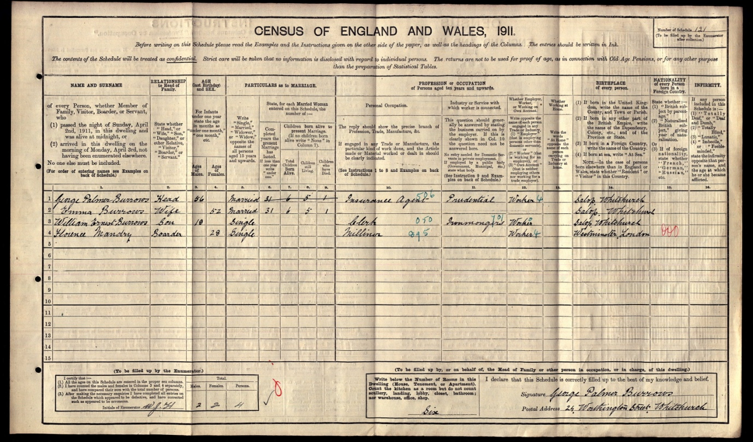

William Ernest Burrows: 1911 Census Record

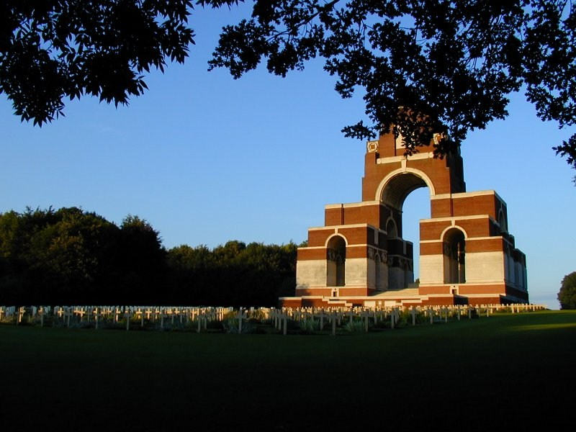

Thiepval Memorial

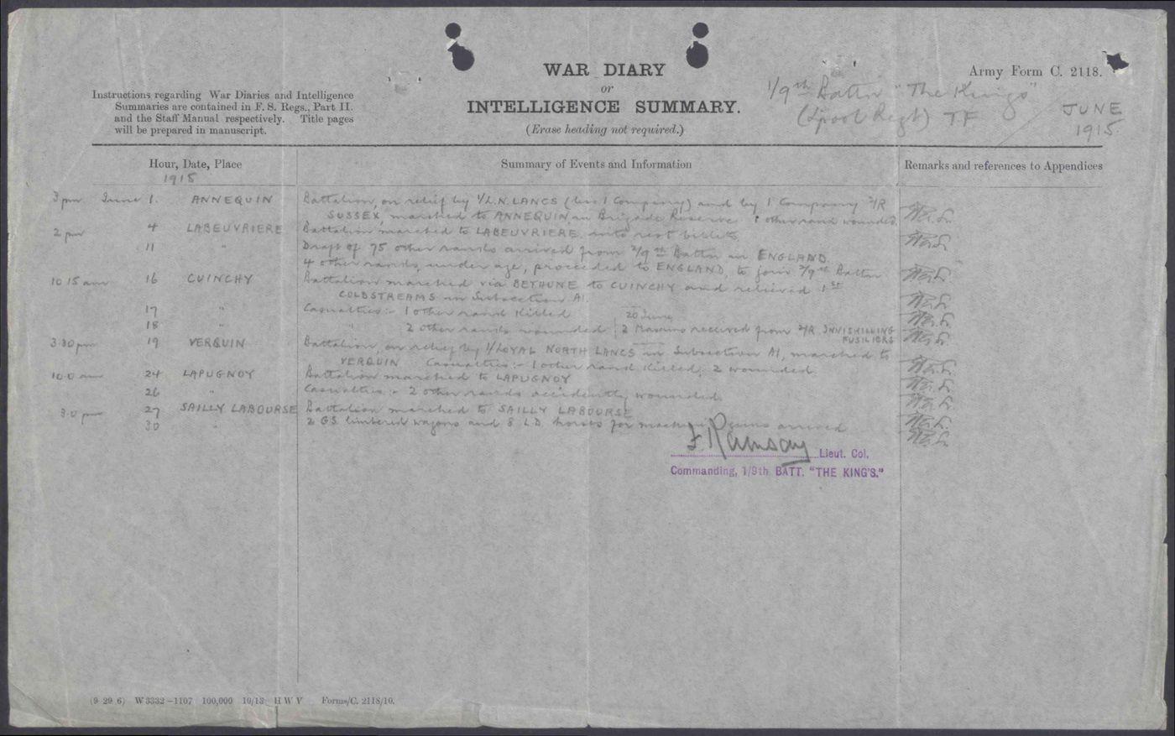
A page from the War Diary of Lieutenant-Colonel F. Ramsay, Commanding Officer of 1/9th Battery of the King’s Liverpool Regiment – the Regiment in which Robert Hales Ridgeway served. Entries - from 1st to 30th June 1915 whilst unit was at Annequin (near Bethune, France) include 1 killed and 4 wounded from ‘other ranks’ (casualties from among the Officers were named).

