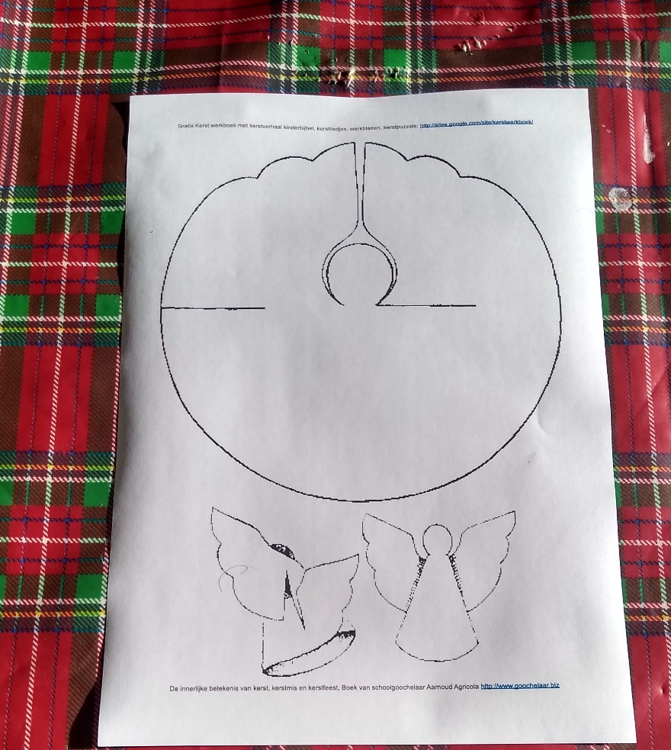
Print out the Template File. A4 is what works best. Paper is OK, thin card may also work.
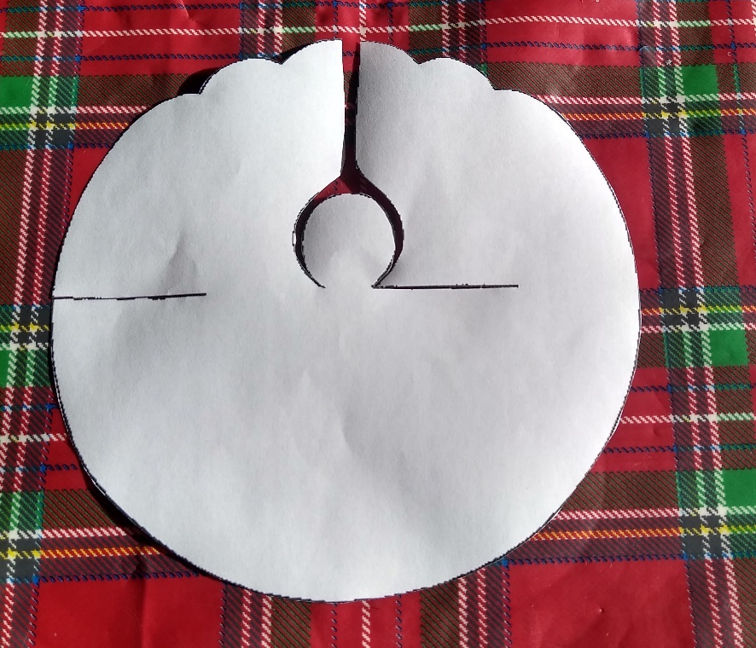

Carefully cut out the template, taking particular care with the section round the head. Cut the slots as marked.
The Angel rolls into a Cone Shape, with the Head sticking up; the slots fit together, making the wings. A small amount of glue helps hold the Angel together. If you’re decorating your Angel, it’s easiest to do it before assembly – just remember that the front of the wings is on the back of the paper! You can make it as simple, or as extravagant, as you like!

