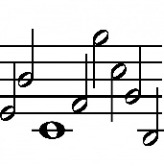
St. John’s Methodist Church
Whitchurch
Present a series of FREE Midday Concerts in May
As follows:
Friday 3rd May: Ukes Aloud followed by a Monologue by David Hack and a ‘Singalong to Show Numbers’ with our resident organist Gwen Reeves.
Friday 10th May: Elaine Gollins and Christopher Jones, Oboe and piano duets. Christopher Jones, organ solo. Poetry and prose with Bob Charlesworth
Friday 17th May: The Tither Recorder Ensemble followed by the Trigelows - Vic, Helen & Rachel.
Friday 24th May: Whitchurch Singers (WS) with a piano solo by Maurice Posniak, a Monologue by Graham Turner, and a solo (supported by the WS) by Stephen Price WS's Lead.

All concerts will be followed by a complementary ploughman’s lunch and your donations will be gratefully accepted

