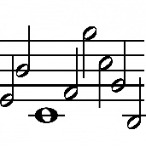

St. John’s Methodist Church

Whitchurch

Present a series of FREE Midday Concerts in May 

As follows:

**Friday 2nd May:** Musicmakers: Trio with Francis Biseker on Flute, Elaine Gollins on Oboe and Christopher Jones on Piano.

**Friday 9th May:** No CONCERT ON FRIDAY 9TH MAY – please support the concert at St. Alkmunds Church

**Friday 16thth May:** Music & Stories with Bill Webb followed by Whitchurch Junior Academy Children’s Choir.

**Friday 23rd May:** The Tither Recorder Ensemble followed by the Trigelows – Helen, Rachel & Vic.

**Friday 30th May:** Whitchurch Singers

**Following the concert your donations will be gratefully accepted and a ploughman’s lunch will be served in the guild room.**

